A Note on Determining ν_{r} from ACCEL Betatron Oscillations
J. Ball – 5/30/05

As I noted in a memo to MLM (4/17/05), an interesting way to calculate the value of ν_{r} is to look at the oscillation period of successive orbit radii as they cross a given azimuth. The ACCEL output gives these values at 90 degrees. It was also noted that it is difficult to pick out the details of these oscillations in the rapidly changing function of radius as a function of turn number, but dividing the value of each radius by the square root of its associated particle energy yields a plot that oscillates about a slowly varying mean.

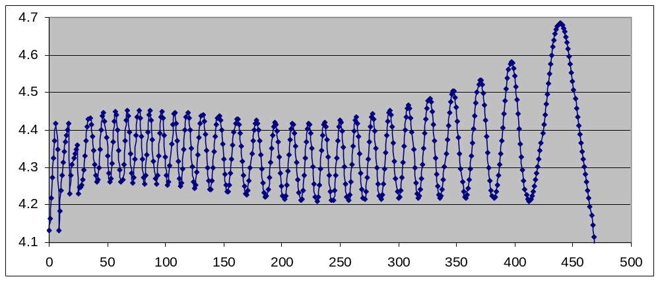
Such curves can then be analyzed to extract the turn position of each maximum. The output of JBACCEL was modified to provide the average radius of each orbit. The turn separation from the peaks was used to calculate ν_{r} from the relationship, ν_{r} = 1 + 1/ΔT, where ΔT is the turn separation. The average turn number, between any two peaks, was then used, along with the average radius vs. turn data, to associate a radius with each calculated value of ν_{r}. These can then be compared with the values of ν_{r} vs. radius calculated by the TCISOC program.
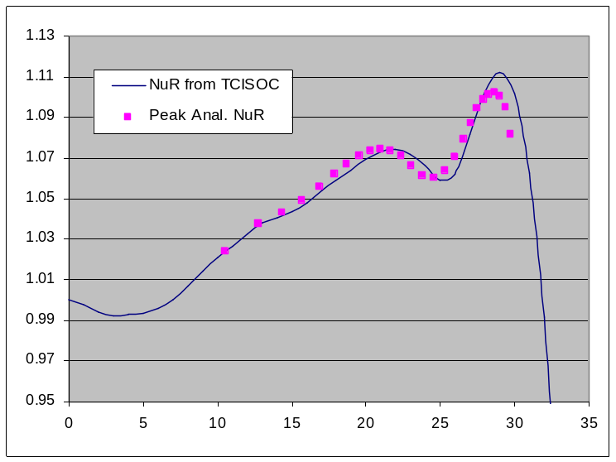
Typical results from this procedure are shown at the right. While the general shape is well reproduced, at larger radii the two curves appear to be shifted by ½ to1 inch, and the final peak from the TCISOC formula is about 10% higher.
One question this comparison raises is just what the radii listed on the ACCEL output represent. Are they the same as an “average” orbit radius or something different?

